EXP 19

**Install a C compiler in the virtual machine created using virtual box / VM Ware Workstation / Player and execute Simple C Programs**

STEP 1: To create the new virtual machine

STEP 2: To install the guest operating system and browse it in the installer disc image file

R.Akash 192121091

STEP 3: Name the virtual machine

STEP 4: Give storage to the disk capacity in a single file

R.Akash 192121091

STEP 5: And the ubuntu virtual machine is created

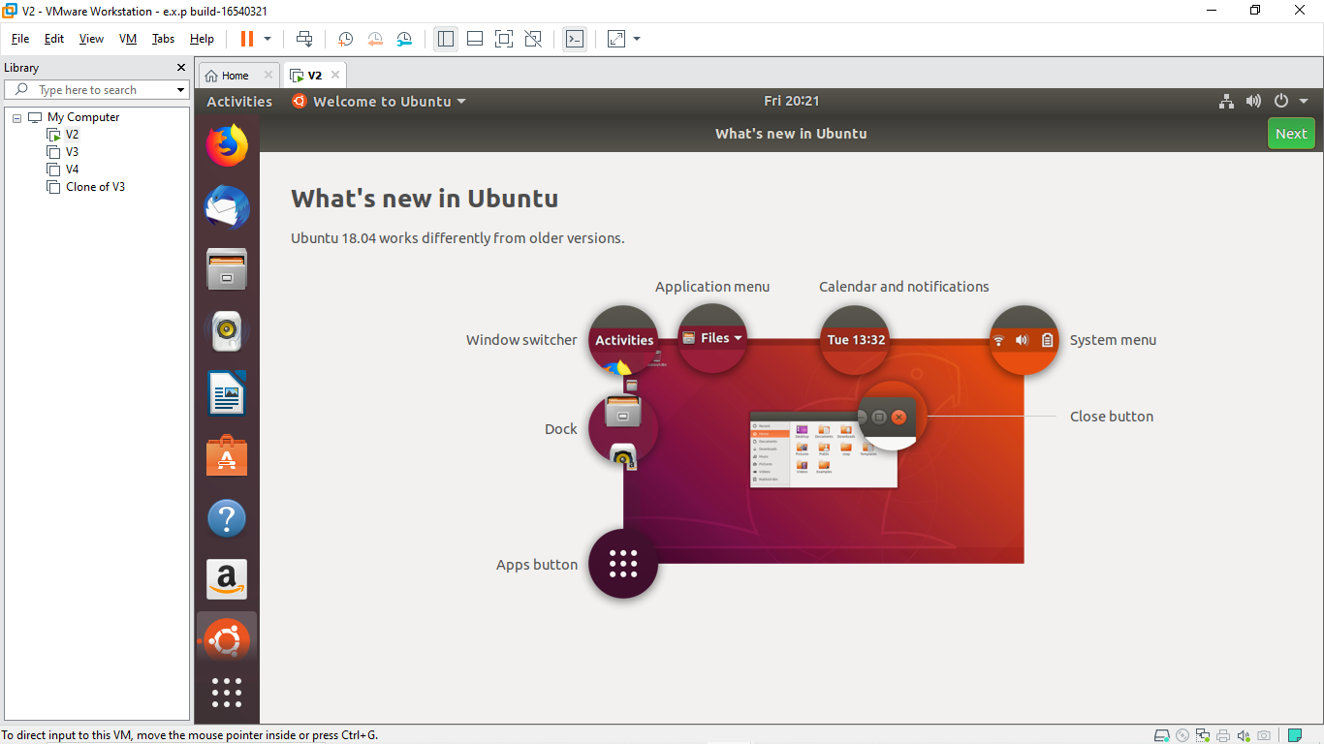

STEP 6: open the terminal and enter the commands

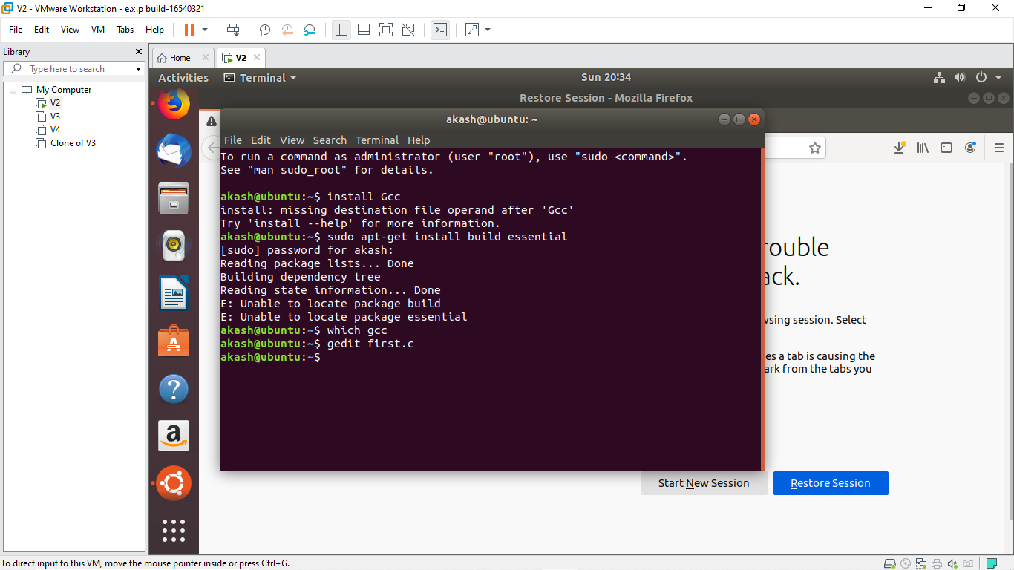

R.Akash 192121091

STEP 7: Enter the c program in the note pad

STEP 8: get the output of the c program

R.Akash 192121091